Day7
Views.html
from django.shortcuts import render
from django.http import HttpResponse

def homepageview(request):
return HttpResponse('<h1>welcome to django</h1>')

def aboutpageview(request):
return HttpResponse('<h2>about us page</h2>')

def contactpageview(request):
return HttpResponse('<h2>contact us page</h2>')
Urls:
"""djangointernship URL Configuration

The `urlpatterns` list routes URLs to views. For more information please see:
https://docs.djangoproject.com/en/3.2/topics/http/urls/
Examples:
Function views
1. Add an import: from my_app import views
2. Add a URL to urlpatterns: path('', views.home, name='home')
Class-based views
1. Add an import: from other_app.views import Home
2. Add a URL to urlpatterns: path('', Home.as_view(), name='home')
Including another URLconf
1. Import the include() function: from django.urls import include, path
2. Add a URL to urlpatterns: path('blog/', include('blog.urls'))
"""
from django.contrib import admin
from django.urls import path,include

urlpatterns = [
path('admin/', admin.site.urls),
path('',include('myapp.urls')),
]
Urls of app:
from django.urls import path
from . import views

urlpatterns = [
path('',views.homepageview,name="home"),
path('about',views.aboutpageview,name="about"),
path('contact',views.contactpageview,name="contact"),

]
Home page

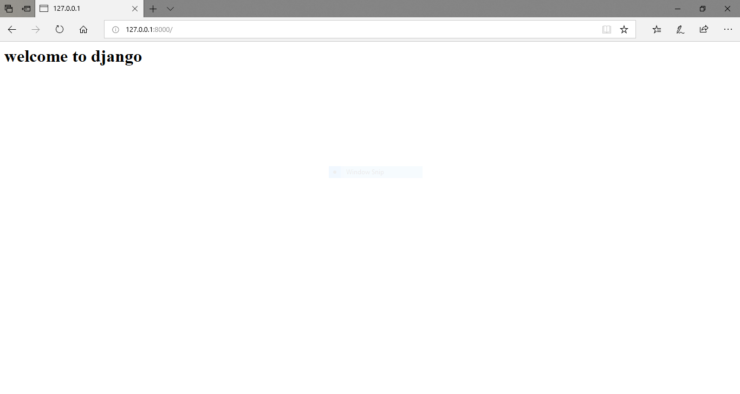
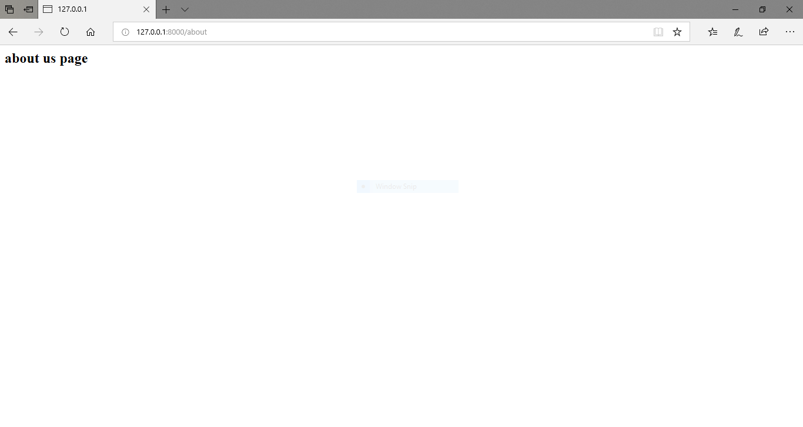
About page:

Contact :

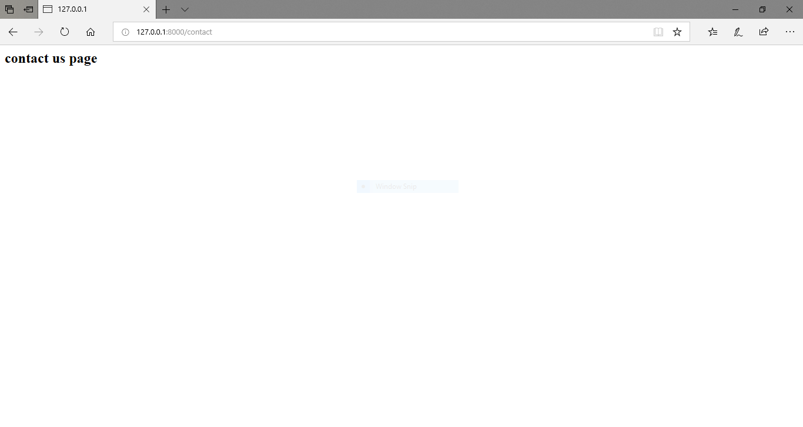

Home page :

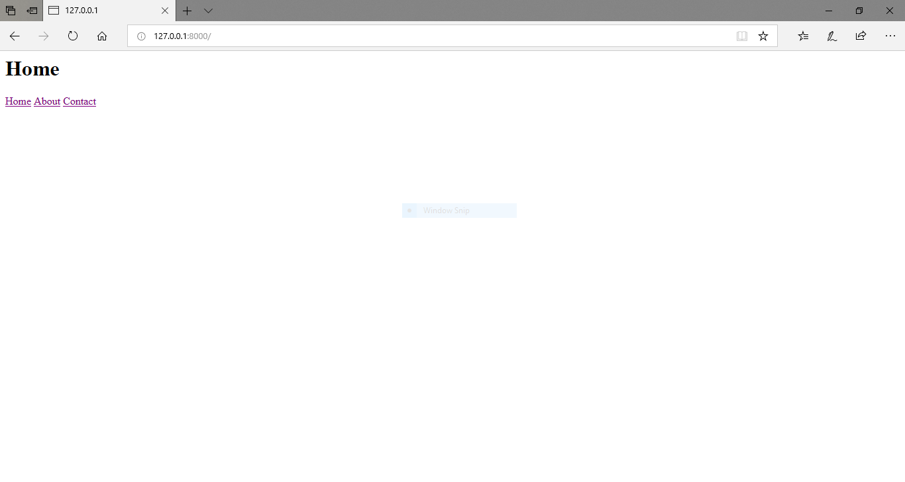

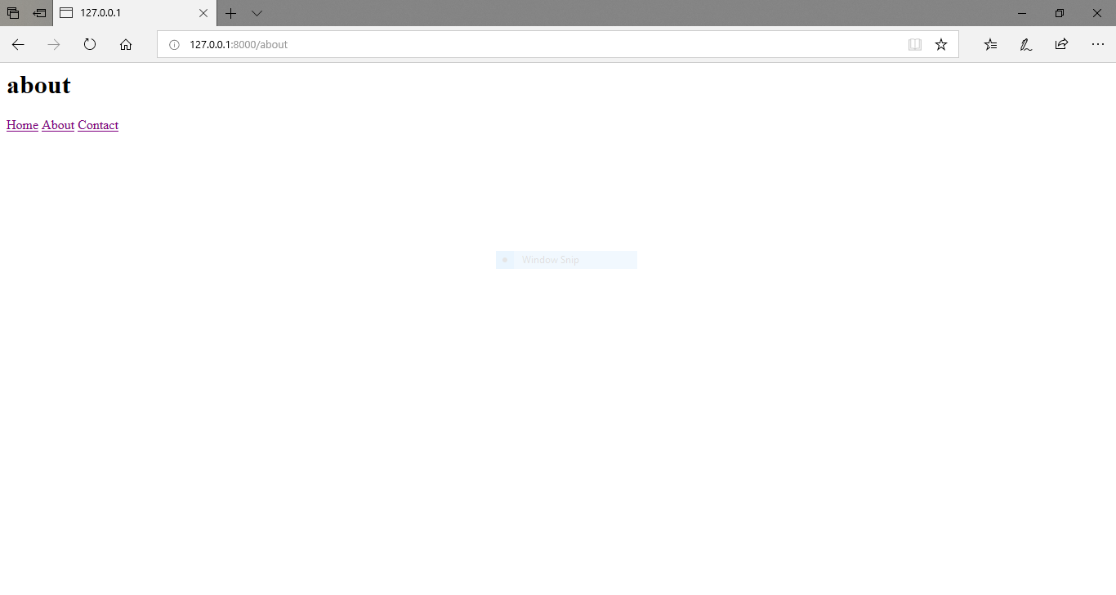

About page:

Contact page :

